**ASSIGNMENT – 4**

1. Write a shell script to find the sum of digits using function.

**Code**:

#!/bin/bas

sum_numbers()

{

sum=0

for num in "$@"; do

sum=$((sum + num))

done

echo "Sum: $sum"

}

echo -n "Enter the numbers: "

read -a nums

sum_numbers "${nums[@]}"

**Output**:

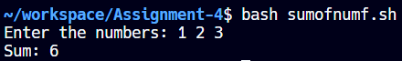

1. Write a shell script to check whether a number is a Palindrome or not using function.

**Code**:

is_palindrome()

{

num=$1

og=$num

rev=0

while [ $num -gt 0 ]; do

digit=$((num % 10))

rev=$((rev * 10 + digit))

num=$((num / 10))

done

if [ $og -eq $rev ]; then

echo "$number is a Palindrome number."

else

echo "$number is not a Palindrome number."

fi

}

echo -n "Enter a number: "

read number

is_palindrome $number

**Output**:

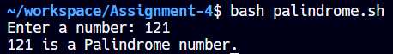

1. Write a shell script to find the prime numbers in a given range using function.

**Code**:

#!/bin/bash

is_prime()

{

num=$1

if [ $num -lt 2 ]

then

return 1

fi

for ((i = 2; i * i <= num; i++))

do

if ((num % i == 0))

then

return 1

fi

done

return 0

}

echo -n "Enter the lower bound:"

read lower

echo -n "Enter the upper bound:"

read upper

echo "Prime numbers between $lower and $upper are:"

for ((n = lower; n <= upper; n++)); do

is_prime $n

if [ $? -eq 0 ]; then

echo -n "$n "

fi

done

echo

**Output**:

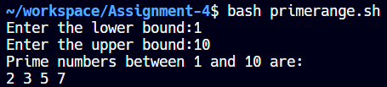

1. Write a shell script to implement bubble sort using function.

**Code**:

#!/bin/bash

bubble_sort()

{

n=${#nums[@]}

swapped=1

while [ $swapped -eq 1 ]

do

swapped=0

for ((i = 0; i < n - 1; i++))

do

if ((nums[i] > nums[i + 1]))

then

temp=${nums[i]}

nums[i]=${nums[i + 1]}

nums[i + 1]=$temp

swapped=1

fi

done

done

}

echo -n "Enter numbers separated by space:"

read -a nums

bubble_sort

echo "Sorted array: ${nums[@]}"

**Output**:

